CSE 326 INTERNET PROGRAMMING LABORATORY

SYNOPSIS

Project Title: Learning Management System

Submitted to: Kunj Marken Mam

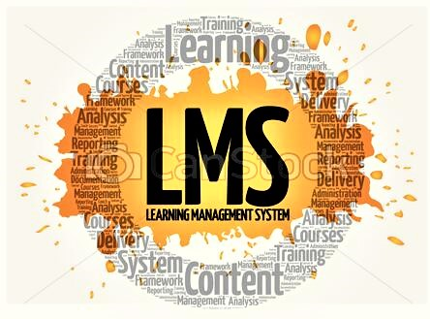

***The Sky is No Limit to Your Learning***

**Group:8**

|  |  |  |
| --- | --- | --- |
| Registration No | Name | Roll No |
| 11904419 | Kalluri. Sai Dinesh | K19JCA23 |
| 11904508 | Vamshi Krishna | K19JCA24 |
| 11904531 | Shivani Kumari | K19JCA25 |

Introduction:

A **learning management system**, (LMS) is a software that is designed specifically to create, distribute, and manage the delivery of educational content. The LMS can be hosted as a stand-alone product on the company server, or it can be a cloud-based platform that is hosted by the software firm.

Overview:

A **learning management system** (**LMS**) is a software application for the administration, documentation, tracking, reporting, and delivery of educational courses, training programs, or learning and development programs. The learning management system concept emerged directly from e-learning. Although the first LMS appeared in the higher education sector, the majority of the LMSs today focus on the corporate market. Learning Management Systems make up the largest segment of the learning system market. The first introduction of the LMS was in the late 1990s.

Module-Wise Work Distribution:

* Sai Dinesh: Home Page

Feedback Page

* Vamshi Krishna: Registration Page

Refer a Friend

* Shivani Kumari: Contact us

Why we need Learning Management System.

Module-Wise Description:

* Home Page (Landing Page):

This page would contain the basic information about the entire Learning Management System and it would contain show case the management system login credentials. It would also have a 'forget password' link for user convenience. It would contain several tabs for registration, help desk and other features. It would also showcase a "Find the management" system with all the required entries. It would display the entire learning management system and provides interactive links like-'What you want to study and user-feedback option.

* Feedback Page:

This page would take the feedback from the users regarding the overall management and effective functioning of the website after taking mandatory inputs from the user-end.

* Registration Page:

This page is meant for the registration of the new users(students). The users need to enter their valid details in the respective fields and if they do the registration process successfully, they get officially registered on the website.

* Why we need Learning Management System?

The learning Management System lets you store all your content in one place, reducing the risk of losing important data, and even making organizing it a very easy task. Each eLearning management team member or other users can then access information, data, or anything else through the cloud storage system LMS can range from systems for managing training and educational records to software for delivering online or hybrid college courses. Choosing a learning management system can be costly and time consuming for many businesses and professionals. These are a few common organizations requirements when seeking an LMS.

* Refer a Friend:

This page would provide the existing users an option to recommend the website to their other friends. They can contact their friends through email-attachments and the social media to expand the network area of the website.

* Contact us:

This page is built for user-convenience and to help them with every aspect of the website. User can fetch information and assistance related to the website through this helpdesk.

Gantt Chart

**SWOT ANALYSIS:**

Strength: Provides a central and manageable system for online and offline training, capable of integrating with the workflow. Works excellent for course management, delivery and tracking of formal learning.

Weakness: Focused on control and managing more than learner experience. Not ready for web experience and offers outdated way of course access. Focused on formal learning to be pushed to learners.

Opportunities: To create learner-centric environments rather than centralized course delivery system through Social and informal learning. To offer talent management functionality in the context of both formal and informal learning.

Threats: Slow to respond to changing learner need, social networking tools. Tools focused on providing a networked environment to learners and allowing them to share content, opinions and information with each other could extend to take over some of the LMS functionality posing a new competition to LMS.